**Agile Methodology**

**What is Agile?**

Agile is a software development methodology centered around iterative development, where requirements and solutions evolve through collaboration between cross-functional teams. Unlike traditional waterfall methods that follow a strict linear path, Agile is flexible, adaptive, and focused on delivering working software frequently.

**Core Principles (from the Agile Manifesto)**

• Individuals and interactions over processes and tools

• Working software over comprehensive documentation

• Customer collaboration over contract negotiation

• Responding to change over following a plan

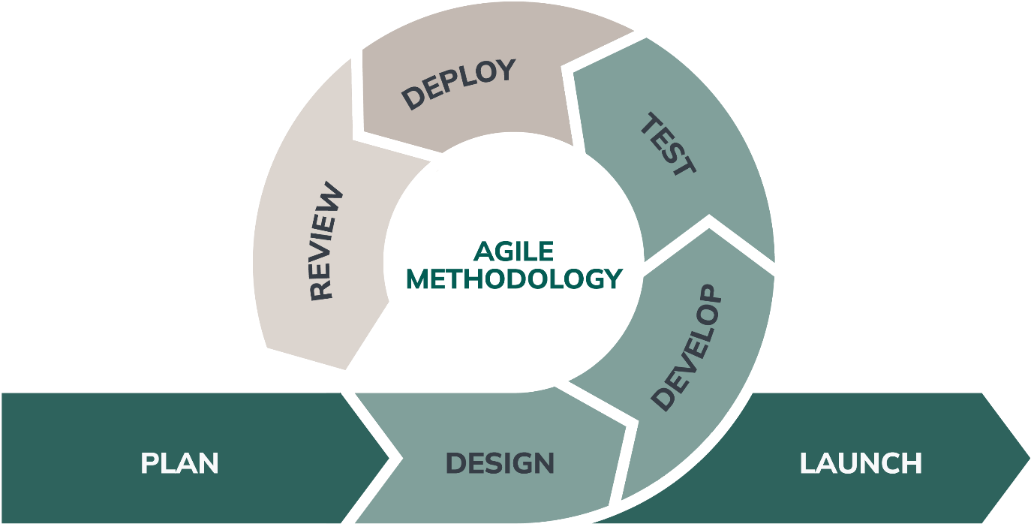

**Agile Frameworks and Process**

**Popular Agile Frameworks**

**• Scrum:**

* Most widely used
* Work divided into Sprints (2-4 week cycles)
* Roles: Product Owner, Scrum Master, Development Team
* Events: Sprint Planning, Daily Scrum, Sprint Review, Sprint Retrospective

**Kanban**:

* Visual board with **columns for workflow stages**
* Focus on **continuous delivery**, limiting Work In Progress (WIP)

Agile Workflow Overview

1. **Product Backlog**: List of features or tasks
2. **Sprint Planning**: Select tasks for current sprint
3. **Sprint Execution**: Develop, test, integrate
4. **Daily Stand-ups**: Quick progress sync
5. **Sprint Review**: Demo completed features
6. **Sprint Retrospective**: Reflect & improve

**Conclusion**

Agile is more than just a process—it’s a **mindset**. When done right, it brings together teams, customers, and stakeholders to build **valuable software faster and better**. But remember, using Jira doesn't make you Agile any more than wearing gym clothes makes you fit.